Unique Weather Hazards over the Northeast Olympic Peninsula

The Northeast corner of the Olympic Mountains creates a zone resulting in some unique and unusual weather. This is due to topography combined with local weather patterns. This often results in hazards to aircraft including turbulence, roll clouds, convergence zone, convective activity, small hail, severe turbulence, windshear and low ceilings.

Area of particular concern depicted in red.
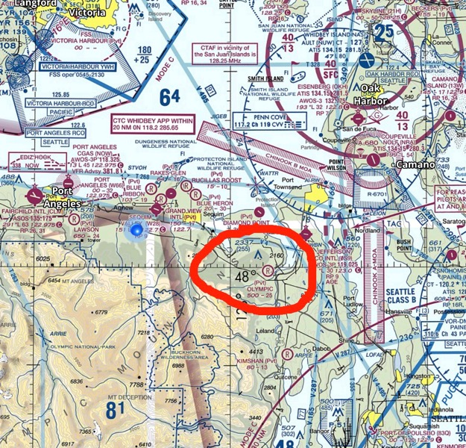

Overhead view shows southerly low-level winds below 3000’ being compressed as it moves north by the Olympic Mountains due to mountainous terrain stretching northeast. This southerly flow occur often occurs with low pressure off of the coast. These winds become more southwesterly above 3000 feet and are unstable due to mechanical turbulence created by winds descending off of the mountains.
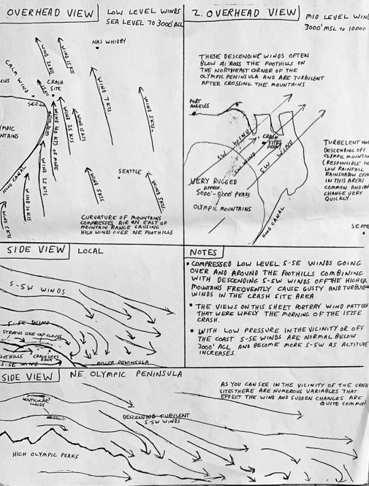

There have been at least 6 fatal crashes where weather and flight into IMC conditions were likely a contributing factor.
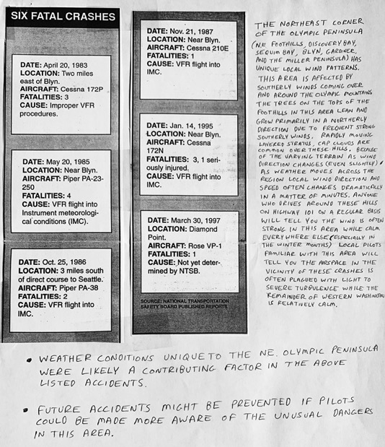

Future Accidents might be prevented in the future by pilots keeping in mind the following:
- Ongoing study and pilot education with regards to a good understanding of local weather patterns
- Pilots using weather resources including radar, weather reports, PIREPS and forecasts with particular attention to Port Townsend, and Paine Field weather conditions
- Caution should be exercised any time there is low pressure approaching from the south or west
- Monitoring cold fronts which often create a convergence zone somewhere between Sequim Bay and Seattle during and up to a day after frontal passage
- Keep in mind that there is often low ceilings and turbulence around Sequim Bay, Discovery Bay, Port Townsend and Hood Canal even with light winds and high ceilings in Port Angeles and Seattle
- Unusual weather can form any time of the year on the northeast side of the Olympic Mountains
- Use common sense and stay out of the clouds, with particular vigilance at night

